🧪 LAB: Launch EC2 & Connect via SSH (Hands-On)
🎯 Objective
- Launch EC2 instance
- Create key pair
- Connect using SSH
- Verify access

🛠️ TOOLS REQUIRED
- Amazon Web Services account
- Linux terminal (Kali / Ubuntu / Mac)
- Internet browser

⏱️ LAB TIME: 20–30 Minutes

🚀 PART 1: LAUNCH EC2

🔹 Step 1: Open EC2
- Login to AWS
- Search → EC2
- Click → Launch Instance

🔹 Step 2: Configure Instance
- Name: my-server
- AMI: Ubuntu Server
- Instance Type: t2.micro (Free Tier)

🔹 Step 3: Create Key Pair 🔐
- Click: Create new key pair
- Name: my-keypair
- Type: RSA
- Format: .pem
👉 Download and save

🔹 Step 4: Configure Network
Enable:
- Auto-assign Public IP ✅

🔹 Step 5: Security Group (IMPORTANT)
Add:
Type | Port | Source
SSH | 22 | My IP
HTTP | 80 | Anywhere

🔹 Step 6: Launch Instance 🚀
- Click → Launch
- Wait until status = Running
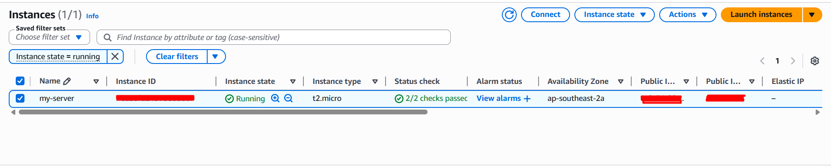

🔌 PART 2: CONNECT VIA SSH

🔹 Step 1: Open Terminal
On Kali / Linux:
cd ~/Desktop

🔹 Step 2: Set Permission
chmod 400 my-keypair.pem


🔹 Step 3: Connect
ssh -i my-keypair.pem ubuntu@<public-ip>
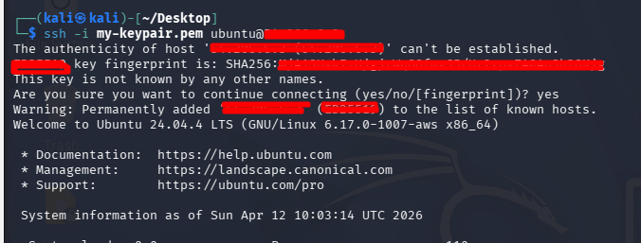

🎉 Expected Output
ubuntu@ip-xxx-xxx-xxx:~$
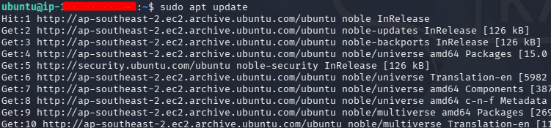
👉 You are inside EC2

🧪 PART 3: VERIFY CONNECTION
Run:
whoami
👉 Output:
ubuntu

Run:
hostname -I
👉 Shows private IP

🌐 PART 4: INSTALL NGINX (BONUS)

sudo apt update
sudo apt install nginx -y

🔹 Test Website
Open browser:
http://<public-ip>
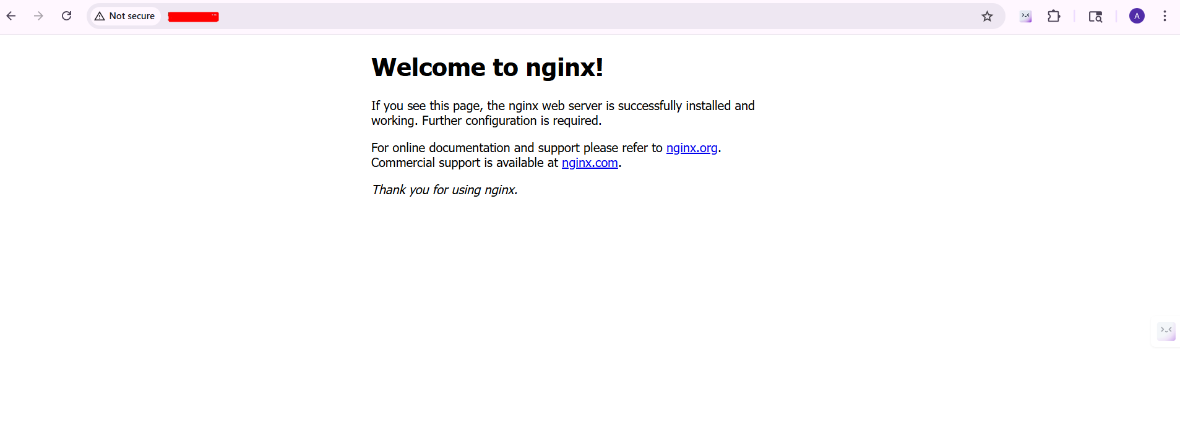
🎉 You’ll see Nginx page

🧹 PART 5: CLEANUP (IMPORTANT 💰)
After practice:
- Stop or Terminate EC2
- Delete unused resources

🧠 LEARNING OUTCOME
After this lab, you understand:
✅ EC2 basics
✅ Key pair usage
✅ SSH connection
✅ Security groups
✅ Basic server setup

🗣️ INTERVIEW READY LINE
👉
"I have hands-on experience launching EC2 instances, configuring key pairs, connecting via SSH, and deploying a basic web server using Nginx."

LAB: IAM Role → EC2 Accessing S3 (No Access Keys)
🎯 Objective
- Create S3 bucket
- Create IAM Role
- Attach role to EC2
- Access S3 from EC2 using role

🛠️ Tools
- Amazon Web Services
- Your existing EC2 instance (SSH already working)

⏱️ Time: 25–30 minutes

🚀 PART 1: CREATE S3 BUCKET

🔹 Step 1: Open S3
- Go to S3 → Create bucket

🔹 Step 2: Configure
- Name: iam-ec2-lab-bucket-<yourname>
- Region: same as EC2
👉 Click Create bucket
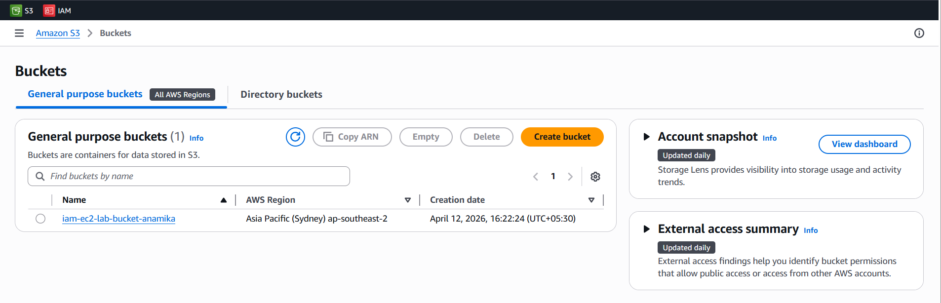

🔹 Step 3: Upload File
Upload:
- index.html
Example content:
<h1>Hello from S3 via IAM Role 🚀</h1>
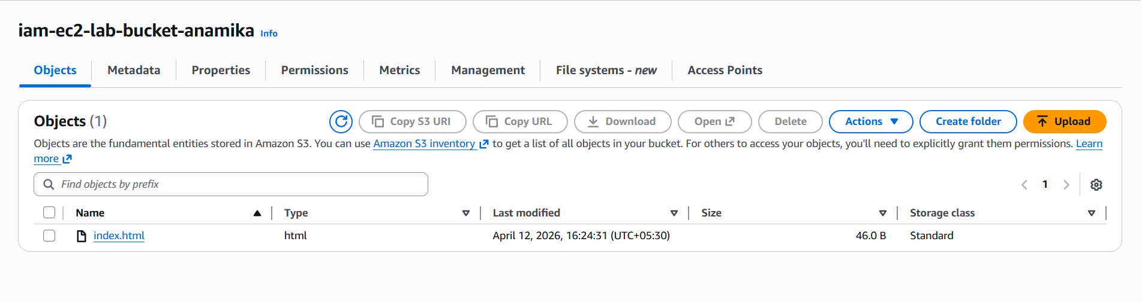

🔐 PART 2: CREATE IAM ROLE (CORE STEP)

🔹 Step 1: Go to IAM
- IAM → Roles → Create Role

🔹 Step 2: Select Trusted Entity
- Choose: AWS service
- Use case: EC2

🔹 Step 3: Attach Policy
For learning, select:
- AmazonS3FullAccess ✅
👉 (Later we’ll restrict this)

🔹 Step 4: Name Role
- Name: EC2-S3-Access-Role
👉 Create role
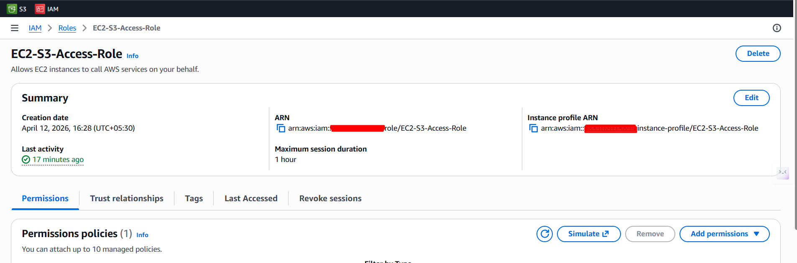

🔗 PART 3: ATTACH ROLE TO EC2

🔹 Step 1:
- Go to EC2 → Instances
- Select your instance

🔹 Step 2:
Click:
👉 Actions → Security → Modify IAM role
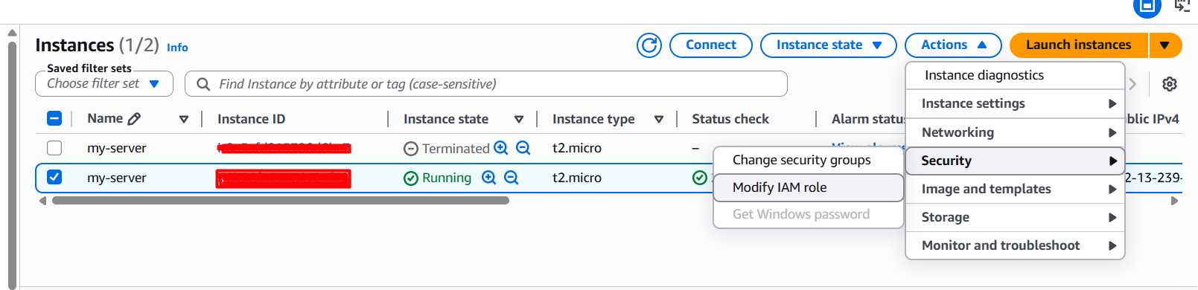

🔹 Step 3:
- Select: EC2-S3-Access-Role
- Save
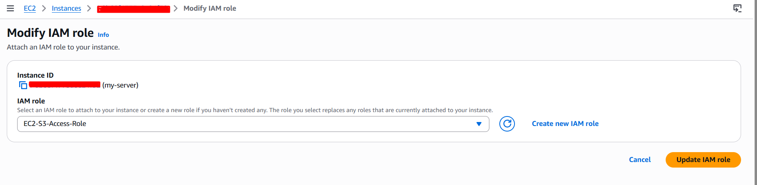

🧪 PART 4: TEST FROM EC2

🔹 Step 1: SSH into EC2

🔹 Step 2: Install AWS CLI (if not present)
sudo apt update
sudo apt install awscli -y

🔹 Step 3: Test Access
aws s3 ls
🎉 You should see your bucket

🔹 Step 4: Copy file from S3
aws s3 cp s3://iam-ec2-lab-bucket-<yourname>/index.html /var/www/html/index.html

🔹 Step 5: Open browser
http://<your-public-ip>
🎉 You should see:
👉 “Hello from S3 via IAM Role 🚀”
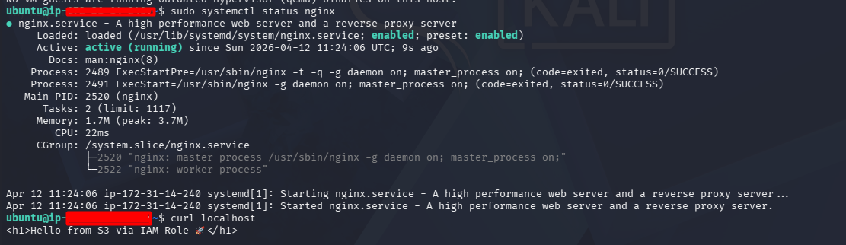
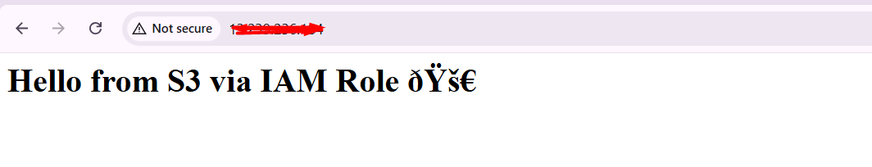

🔥 WHAT JUST HAPPENED (VERY IMPORTANT)
👉 EC2 accessed S3 WITHOUT:
- ❌ Access keys
- ❌ Passwords
👉 Because:
- IAM Role gave temporary secure credentials

🧠 KEY CONCEPTS LEARNED
✅ IAM Role for EC2
✅ Secure access without keys
✅ S3 integration
✅ Real DevOps architecture

❌ COMMON ERRORS

🔴 Access Denied
👉 Check:
- Role attached properly
- Policy attached

🔴 aws command not found
👉 Install AWS CLI

🔴 File not updating
👉 Restart nginx:
sudo systemctl restart nginx

🗣️ INTERVIEW READY ANSWER
👉
"I implemented IAM roles for EC2 to securely access S3 without using access keys. I attached the role to EC2 and validated access using AWS CLI, ensuring a secure and scalable architecture."

